Schools' Robotic Competition Singapore Robotic Games 2006
schools' robotic competition -
robo can - collector
New Field
1. OBJECTIVE
To design and build an autonomous robot that is able to follow a black path. At the end of
the path, it is to collect a can of 200g (5% fluctuation) weight and to return to the starting box
before unloading.
2. JUDGING CRITERIA
The robot that is able to collect the most number of ''cans'' within the stipulated time of
FIVE minutes is the winner.
3. rules and requirements
- The robot is to be controlled by an on-board programmable microcontroller and powered
by 6 AA batteries or its equivalent of 9V (6 x 1.5V). The robot should not exceed 25 cm
in length and width.
- The field (Figure 1) is of a rectangular shape with an approximate size of 176 cm by 144
cm, and is constructed using the proprietary Plegofield (www.plegofield.com). There is a
black path (on white background) leading to 5 separate paths, at the end of which 1 ''can''
is pre-loaded on one of these five rocker arms (Figure 2). There is also a starting box
measuring 25 cm by 25 cm at one end of the field where the robot would start and finish.
- The robot should be designed to negotiate and follow the black path. Obstacles would be
placed randomly by the judges just before competition commences to prevent robot from
taking ''short cut'' to reach the ''can''. Other fixed obstacles (Figure 3) are placed near the
end of each path. Upon reaching the end of path, the robot has to collect this ''can''
(loaded on 1 of the 5 rockers). Robot should make contact with the rocker arm to dis-
lodge the 200g ''can'' onto its receptacle. Robot must then carry the ''can'' (off the
ground), and bring it back to the starting box. Upon reaching the finishing position (when
any part of the robot body touches the starting box outline) the 200g ''can'' is unloaded by
the handler and robot repositioned within the starting box to start the next run to collect
the next ''can''. The ''can'' will be placed on one of the 5 available positions by the judge
during the time the robot makes its return run. 1 200g ''can'' is to be collected for each
run and only 1 handler is allowed to assist the robot at the starting and finishing position.
- It is considered an aborted run should the robot drop its can on the field in the course of
its run. The robot is to start from the starting position and to collect the can that is placed
on the any rocker arm by the judge.
- The robot is given 5 minutes to collect as many cans as possible.
- No adjustment is allowed in the open field during the run. The robot must be brought
back to the starting box and restart when being inactive, disabled or out of control in the
open field. This will be considered as one aborted run, and the decision to abort the run is
at the discretion of the handler.
- Permission may be granted for 1 recess (10 minutes) and it carries a penalty of 2 minutes
on the competition time.
- In the event of a tie, the robot with the least number of aborted runs during the game will
be ranked the highest. On further tie, the rank will be determined by either the shortest
46 28 November 2005

Schools' Robotic Competition
Singapore Robotic Games 2006

time for a successful collection or the furthest distance covered for a non-delivery, of
ONE final run.
3.9 Each school could submit 3 entries and no cloning (identical design) is allowed. Entry
closes two weeks before the competition. The robot must pass inspection at the
beginning of the competition. Further details are available from the official web site.
3.10A11 robots shall be caged at the beginning of the competition and will be returned only at
end of the entire competition.
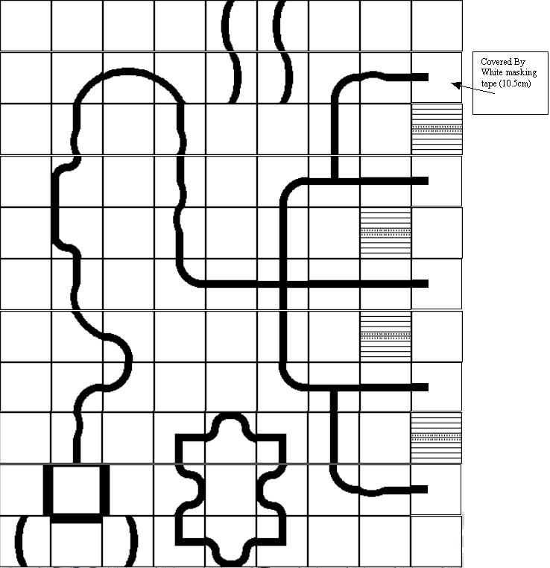
Figure la: The Field*

* From Plegofield, (http://www.plegofield.com)

47

Schools' Robotic Competition
Singapore Robotic Games 2006

Figure 1b: The Field
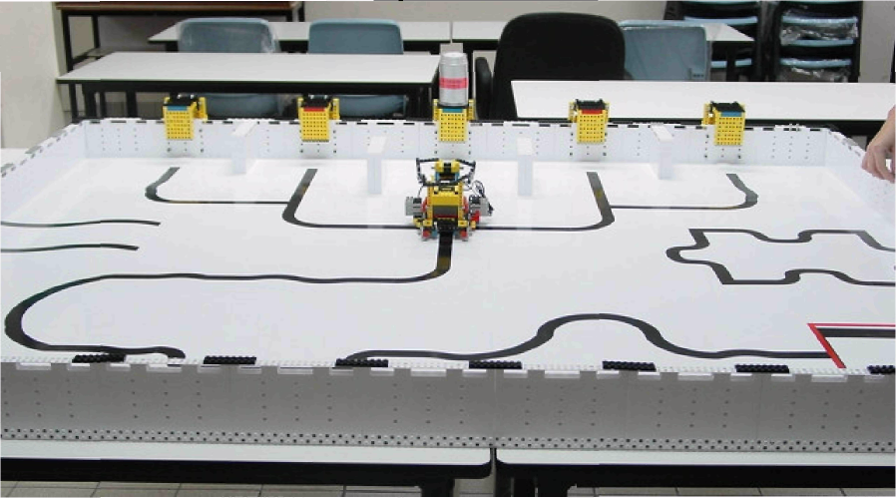
Figure 2: The Rocker Arm

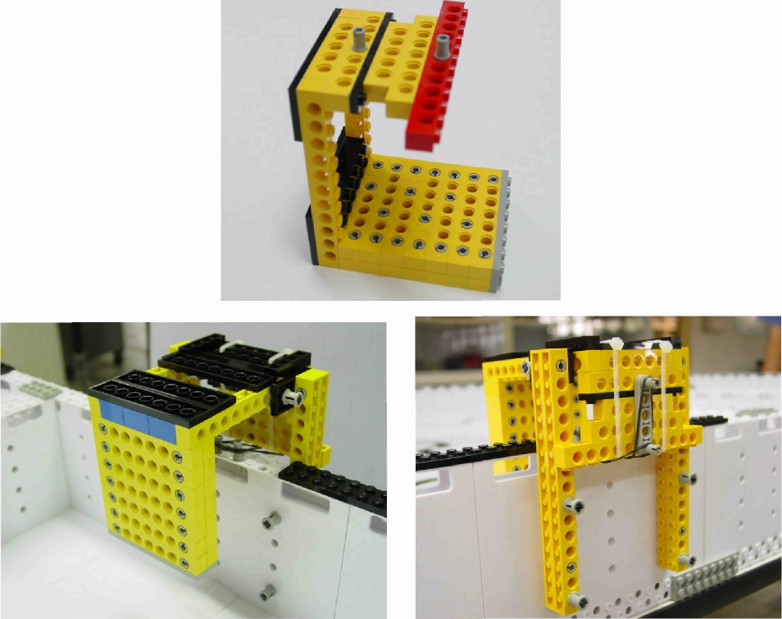

Rocker Arm Front View
Rocker Arm Back View

48
28 November 2005

Schools' Robotic Competition
Singapore Robotic Games 2006

Figure 3: Fixed obstacle

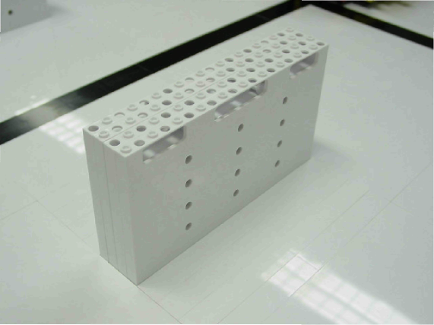

49
28 November 2005

